SE LAB 4
NAME: Saathvik Shenoy Padubidri
SRN:PES1UG24CS394
SECTION:G
Assigned Github Repo: https://github.com/SETAPESU26/24_treasure_hunt
BEOFRE VIDEO:
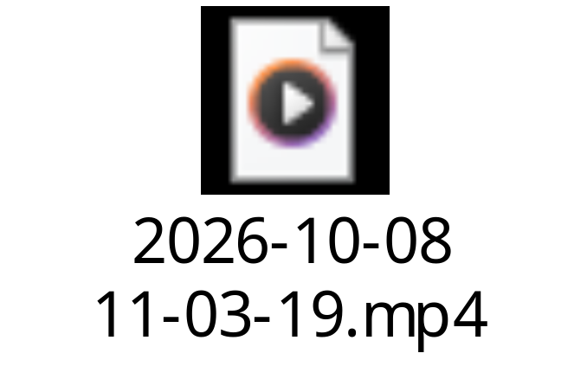

After Video:
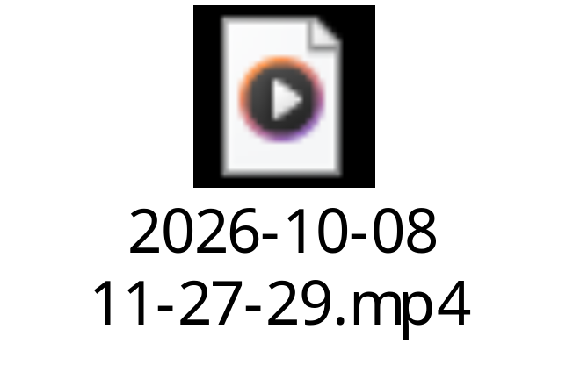

Public LLM Link:
https://chatgpt.com/share/6ac7ce46-f21c-83e8-b5b8-c7fe50e06ad1

Features/Bug Fixed Snippet:
Task 1: Traps
What was added
- A new tile type, TRAP, drawn as a dark-red tile with three white spikes.
- place_traps() puts up to 2 traps in every room except the start room.
- reachable() is a flood fill. A trap is only kept if the key and chest can still be reached without stepping on a trap, so a level is never impossible.
- Stepping on a trap sends the player back to the start, shows a status message, and keeps the key.
Code
WALL, FLOOR, CHEST, KEY, TRAP = 0, 1, 2, 3, 4

# in generate_world(), before returning
place_traps(grid, rooms)
return grid, start, rooms

# in Player
def respawn(self, x, y):
self.rect.topleft = (x, y)

# in GameEngine
def send_to_start(self, message):
self.player.respawn(*self.start_pos)
self.status = message

# in update()
elif cell == TRAP:
self.send_to_start("TRAP! Sent back to start.")
Task 2: Enemy Guard
What was added
- A Guard class that patrols left and right along one row at speed 2, reversing at each end.
- make_guard(rooms) places it in the chest room, on the row just above the chest.
- Touching the guard sends the player back to the start with the message “Guard caught you! Back to start.”
- The guard is drawn as a maroon rounded rectangle with two white eyes.
Code
class Guard:
def __init__(self, left_col, right_col, row, speed=2):
self.left = left_col * TILE + 6
self.right = right_col * TILE + 6
self.rect = pygame.Rect(self.left, row * TILE + 6, 28, 28)
self.speed = speed
self.direction = 1

def update(self):
self.rect.x += self.speed * self.direction
if self.rect.x >= self.right:
self.rect.x = self.right
self.direction = -1
elif self.rect.x <= self.left:
self.rect.x = self.left
self.direction = 1

# in update(), after the player moves
if self.guard:
self.guard.update()
if self.player.rect.colliderect(self.guard.rect):
self.send_to_start("Guard caught you! Back to start.")
return
Task 3: Mini-map
What was added
- draw_minimap() draws the whole grid in the top-right corner at 6 pixels per tile, with a white border.
- It reads the live grid every frame, so the key disappears from the map when collected.
- The player is a blue dot and the guard is a red dot.
Code
MM = 6

def draw_minimap(self):
ox, oy = WIDTH - COLS*MM - 8, 8
pygame.draw.rect(self.screen, (255,255,255), (ox-2, oy-2, COLS*MM+4, ROWS*MM+4))
for r in range(ROWS):
for c in range(COLS):
pygame.draw.rect(self.screen, COLORS[self.grid[r][c]], (ox+c*MM, oy+r*MM, MM, MM))
px = ox + self.player.rect.centerx * MM // TILE
py = oy + self.player.rect.centery * MM // TILE
pygame.draw.circle(self.screen, (60,170,255), (px, py), 3)

# in draw(), right after the player is drawn
self.draw_minimap()
Task 4: Inventory UI

What was added

A 36×36 slot at the right end of the HUD bar.
It is empty at the start and shows a gold key icon (ring, shaft and two teeth) as soon as the key is picked up.
Pressing R resets the game, so the slot empties again.

Code
def draw_inventory(self):
slot = pygame.Rect(WIDTH-50, ROWS*TILE+7, 36, 36)
pygame.draw.rect(self.screen, (40,40,60), slot, border_radius=4)
pygame.draw.rect(self.screen, (150,150,170), slot, 2, border_radius=4)
if self.player.has_key:
cx, cy = slot.center
gold = (220,220,60)
pygame.draw.circle(self.screen, gold, (cx-8, cy), 7, 3)
pygame.draw.line(self.screen, gold, (cx-1, cy), (cx+11, cy), 3)

# in draw(), after the HUD status text
self.draw_inventory()
Bugs Found and Fixed
Bug 1: Traps could block the level. Traps sometimes sealed off the only doorway into a room, making the key or chest unreachable.
- Fix: place_traps() now keeps a trap only if the reachable() flood fill still reaches the key and chest. I tested 1,000 generated levels and none were unwinnable.
Bug 2: The guard walked over a trap. The guard’s patrol row in the chest room could contain a trap.
- Fix: traps are no longer placed on that row.
guard_row = rooms[-1].centery - 1
cells = [(r, c) for r in range(room.y, room.bottom)
for c in range(room.x, room.right)
if grid[r][c] == FLOOR and not (room is rooms[-1] and r == guard_row)]
Testing Done
- Collected the key and opened the chest.
- Stepped on traps and was sent back to the start.
- Touched the guard and was sent back to the start.
- Checked the mini-map and key slot update live, and that R clears the slot.

